**PRACTICAL –5**

**Aim: -** To study HTML LIST, Definition List and Character Entities

**Tags: -**

**1.**<UL>

**2.**<LI>

**3.**<OL>

**4.**<DL>

**5.**<DT>

**6.**<DD>

**Exercises:**

**1.**Demonstrate the use of character entities.

**2.**Write a HTML code to display following output.

**South Asian Countries:**

* India
* Pakistan
* Sri Lanka
* Bangladesh

**3.**Write a HTML code to display following output.

**My hobbies are:**

1. Football
2. Listening Music
3. Reading
4. Cooking

**4.**Write a HTML code to display following output.

* Cakes :
  1. Plain Sponge
  2. Chocolate Cake
  3. Apple Tea Cake
* Biscuits :
  1. ANZAC Biscuits
  2. Jam Drops
  3. Melting Moments

* Breads/quick breads :

a.       Damper

b.    Scones

**5.**Write a HTML code to display following output.

Starts a numbered list:

5.      This is one line

6.      This is another line

7.   And this is the final line

**6.**Write a HTML code to display following output.

LAN

            Local Area Network

WAN

            Wide Area Network

MAN

            Metropolitan Area Network

**7.**Write a HTML code to display following output.

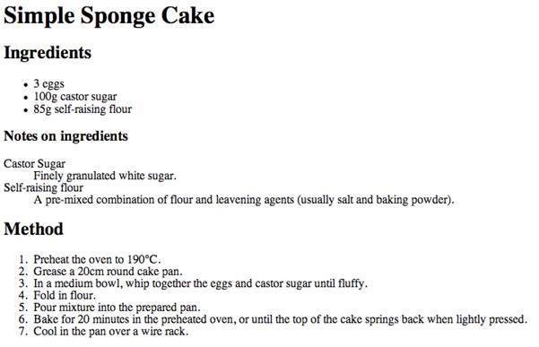

**8.**Write a HTML code to display following output.

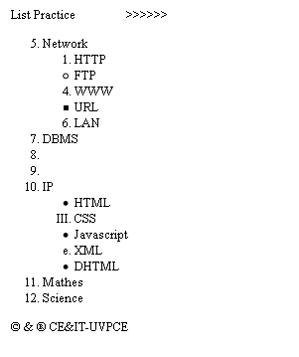

**9.**Write HTML code to develop a webpage which covers all the above tags with all the attributes (values) & tags of Practical-2, 3, 4 also.